Navigate the Mars Rover by Team Clinical Thinkers

Crew Members: Dhanvanth Singaravelu

Rohith Rajesh

Hayma Sunder.P

Mentor: Mr. Ashutosh Upadhyay

**Mission:**

The objective is to help the Mars Rover navigate its shortest way to the destination avoiding all obstacles on its way.

**What we’re solving:**

Keeping in mind, the constraints and the different algorithms, we tried implementing the use case in the efficient way possible.

What our project aims to accomplish is to find the shortest between :

* 1-start 1-destination
* 1-start 2-destinations.

For this we’ve come up with the idea of the Mars Rover being the source and any water resource being the destination, with craters being the obstacles.

Key:

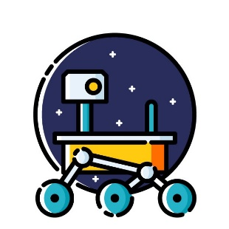 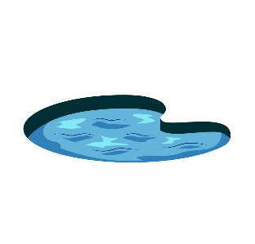

Water Resource (destination)

Mars-Rover (source)

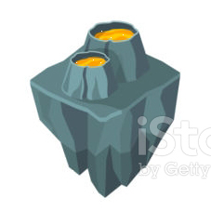

Crater (Obstacle)

Algorithms Used:

* A star
* IDA star
* Breath-First Search
* Best-First Search
* Djikstra
* Jump Point Search
* Orthogonal Jump Point Search
* Trace

**What we’re not solving:**

All these above mentioned algorithms are included in the PF (Path Finding) package installed via npm.

**Changes to the UI:**

1. Added additional end point.
2. Additional Panel added to top left corner of the screen to choose number of destinations (1 or 2).
3. Replaced the green source to Mars Rover Icon.
4. Replaced the red destination to Water Source Icon.
5. Replaced the grey obstacles to Crater Icon.
6. Modifications made to grid and node sizes.
7. Added our GitHub project source code link at the bottom of the screen.

**Front End UI:**

* File Name: index.html
* StyleSheet: style.css

The html consists of :

1. Instruction Panel

A floating panel which gives the user an idea on how to execute the program. Can be hidden with help of hide button floating to the top right corner.

1. Algorithm Panel:

Place which prompts the user with different shortest path algorithms and each algorithm has two sub-divisions under it namely,

* Options

* Heuristics

1. Choice Selector Panel

Additionally equipped in the top left corner of the screen to enable the user to choose the number of destinations.

1. Play Panel

Consists of three buttons namely:

Start Search toggles to (Restart Search)

Pause Search toggles to (Clear Path)

Clear Walls.

Styling for these front end element is done in the style.css file.

**Getting Started with the Backend:**

Files Used: **controller.js, main.js, panel.js, view.js**.

Changes done to the code:

1. Under the State Machine a new event called ‘rebuild’ has been initialized which takes the control from any current state back to the none state.

Which is represented as * 🡪 none;

1. Since our program finds the shortest path for two destinations also, in addition to ‘dragEnd’ we have added ‘dragEndtwo’ which is an event that is active only when rover is in either ready or finished state.
2. View.deleteGrid() is a function added in the controller.js to delete the grid all over every time we leave the ‘none’ state.

Note: This function deletes the grid from the UI.

1. delete this.grid 🡪 Deletes the formed grid from the package Pathfinding.js

Note: This statement deletes the grid from the backend.

1. onsearch: This is the function which actually finds the shortest path between the co-ordinates marked in the grid by the user. Depending on the input value given in the panel placed at the top left corner of the screen, the program finds the shortest path between either one or two destinations respectively.

* If the choice is ‘one’ 🡪 single destination

The type of algorithm which should be employed to find the shortest path is chosen by the user from the UI. This in turn is parsed to object ‘finder’. A fresh grid is cloned to enable the rover traverse the entire mars surface and find its path. Finally the path is generated by sending the grid co-ordinates of the start and the end positions along with the fresh grid we just cloned. This path thus found is stored in variable ‘path’.

* If the choice is ‘two’ 🡪 dual destination

The procedure is followed is here but keeping in mind we have two destinations now. Logic used here is pretty straightforward, the shortest path is calculated thus, first in cloned ‘grid’, the path is found from start to destination 1. Secondly from fresh grid ‘grid2’, the shortest path between start and destination 2 is found. Finally the rover decides on which destination to move first by calculating the shortest between the above found paths. Doing this, another new grid is cloned ‘grid2’ which finds the shortest path from the one destination chosen above to the other, finally merging them both derives us the ultimate shortest path required evading all obstacles on the way.

1. Additional change made is to decide whether to allow or deny the user the ability to move around destination 2. Only when the user selects the two destination option from the above, the second destination displays on the screen and the user has the liberty to change its position anywhere in the grid except for the same position has start and destination 2.

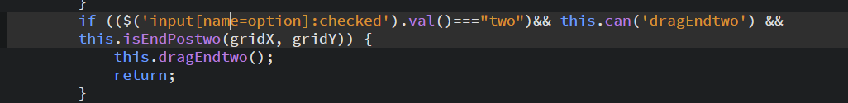

1. On selecting 2 destinations the second destination is enabled to freely move around in the grid and return its final position to the backend via grid co-ordinates.

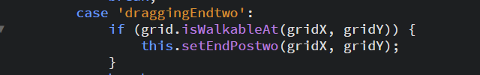

1. Each time the grid shows up to the user, based on the number of destinations selected the default positions of start and end points are placed in the canvas via the below code.

The variables centerX and centerY take up values from the grid and with respect to which the default positions are chosen.

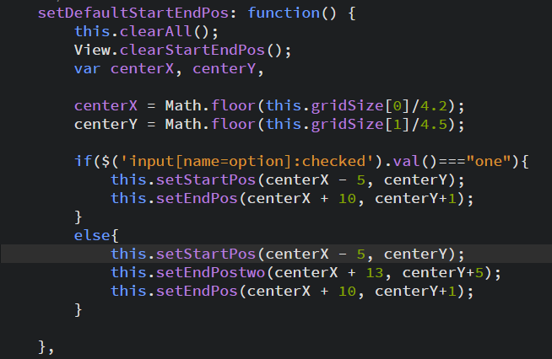

1. View.clearStartEndPos() is a function defined in view.js which on reloading or toggling between options, clears the positions of prevailing start, end node 1 and end node 2 positions whose values may vary depending on the previous search.
2. This code snipped prevents the user from drawing obstacles over the already marked start, and two destinations.

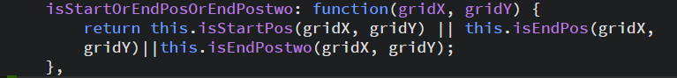

1. Placing the Rover image in start position selected by the user. The grid co-ordinates are being translated to page co-ordinates using toPageCoordinate function and the image used here is pulled from our repository and positioned in place of start node using the co-ordinates and of size (nodeSize* nodeSize). Each time the start node is taken elsewhere on the grid an small zoom effect is give to it.

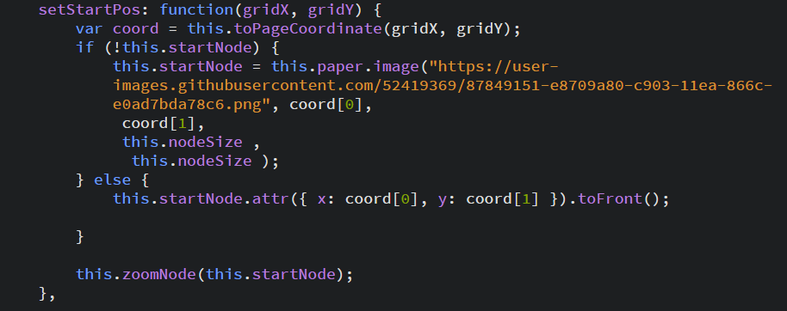

1. In a similar fashion, the water source images set as destinations are positioned.

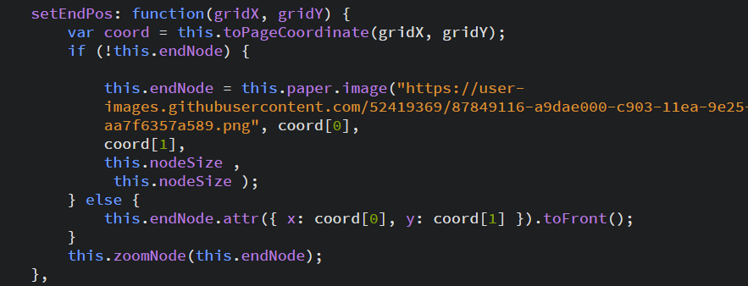

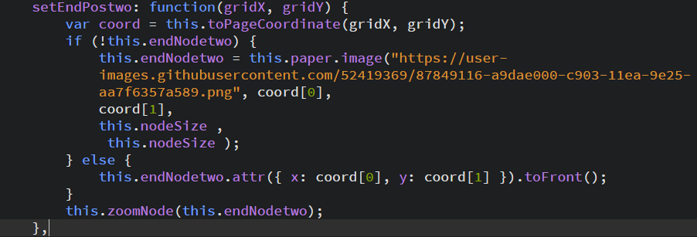

1. The Mars Surface added as background image is set through the following piece of code. Initially after every reload, the image is deleted and drawn again at position margin:0 and of size spanning the entire grid i.e., numCols * nodeSize, numRows * nodeSize.

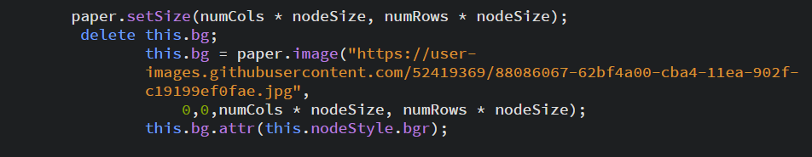

1. The opacity of the background is reduced to 90% by capturing the nodeStyle attribute through bgr.

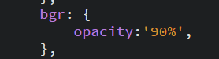

**STATE DIAGRAM**

From the actual diagram given to us, as per the demands of our use case we have modified the state diagram by adding an new event called rebuild which reverts back to ‘none’ state from any of the present states.

Marked through red.

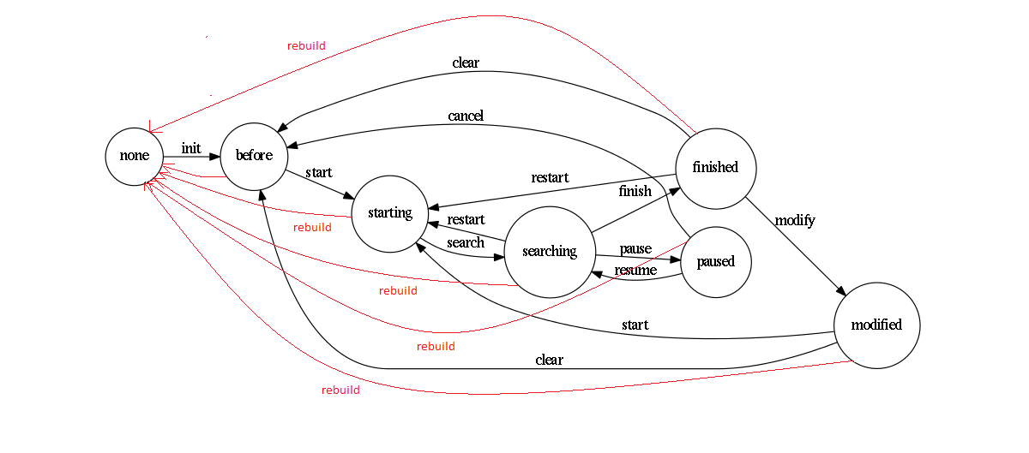

**Screenshots:**

**1) Initial Screen:**

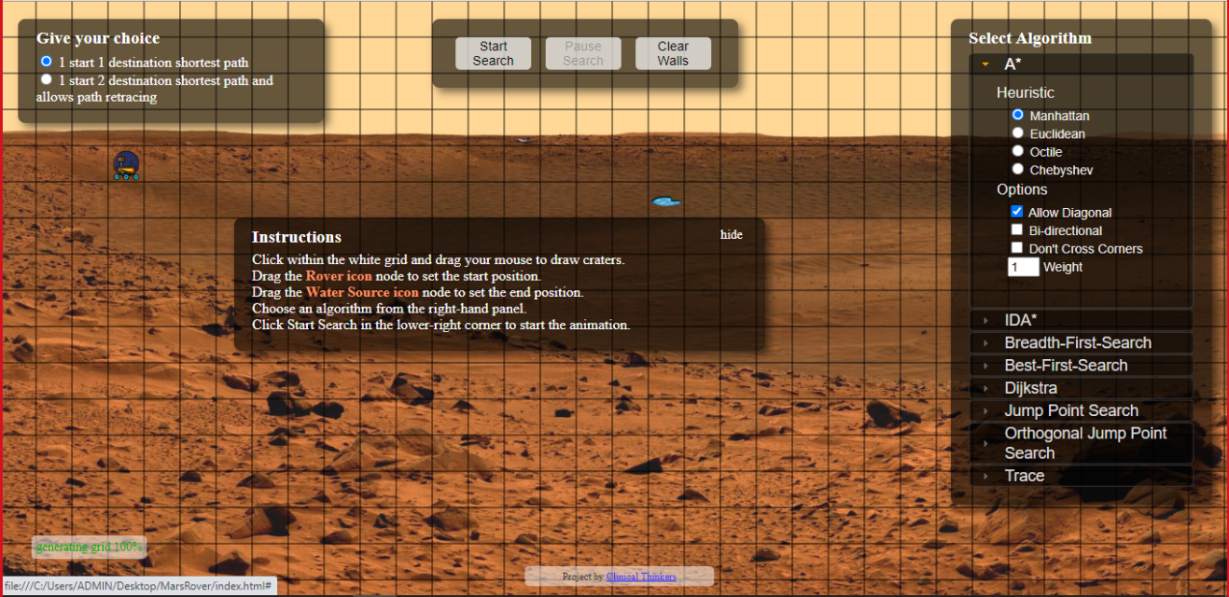

Grid is displayed overlapping which, the choice selector, instruction, play and algorithm panels are placed.

**2) 1 Start 1 Destination Working:**

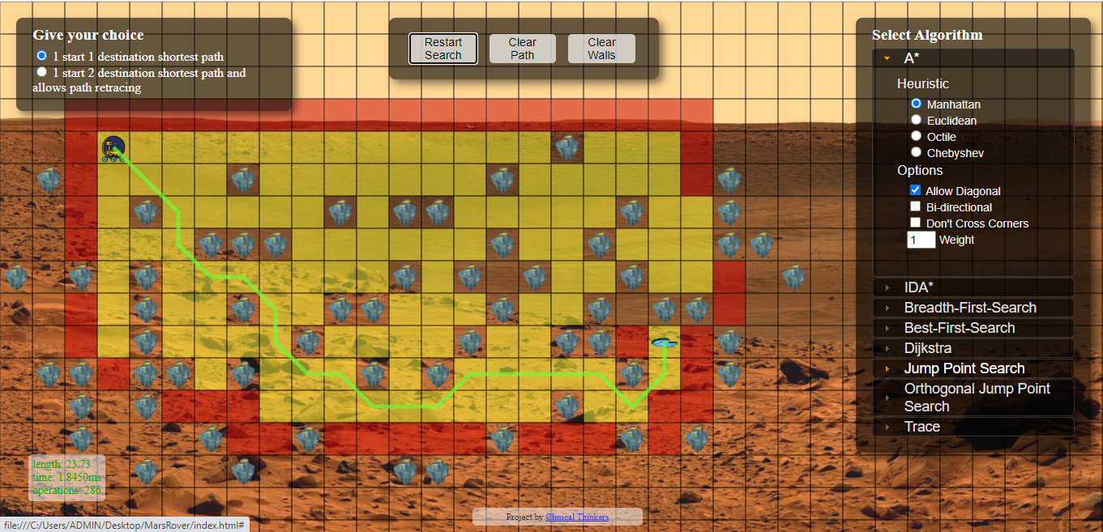

Utilizes the **A\*** algorithm to find the shortest path between one source and one destination, avoiding all obstacles.

**3) 1 Start 1 Destination Working – No Diagonal:**

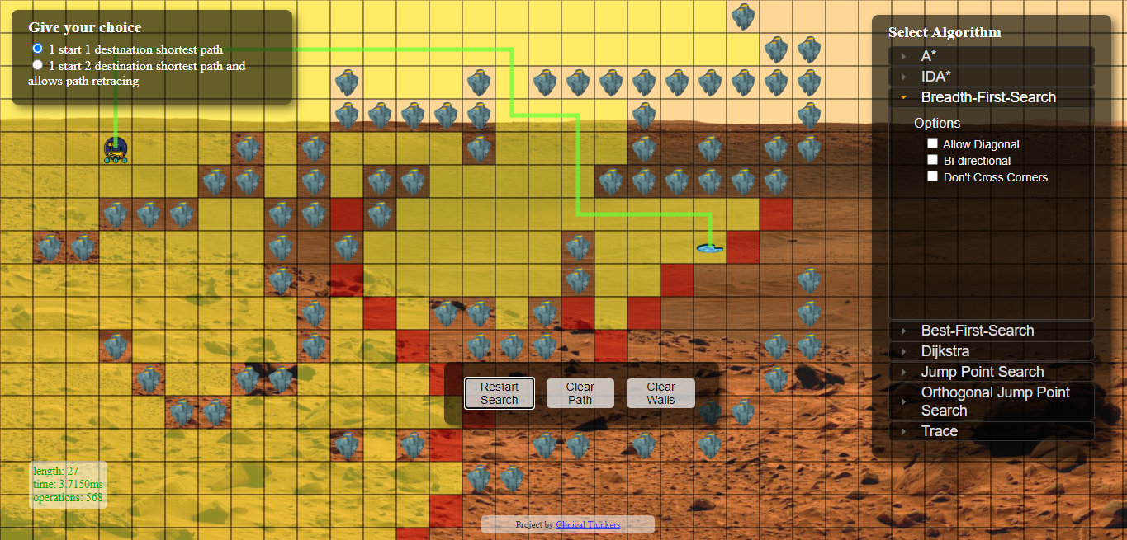

Makes use of **Breath First Search** algorithm to find the shortest path between one source and one destination, not allowing diagonals.

**4) 2 Point Destination Initial Screen:**

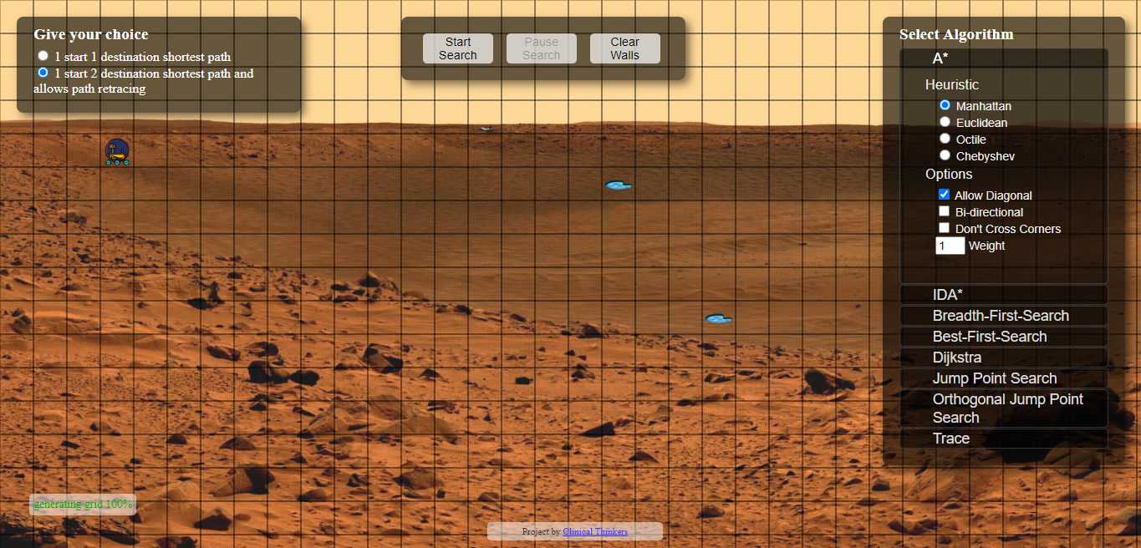

Grid is displayed along with two water resource destinations specified in their default positions.

**5) Two Point Working:**

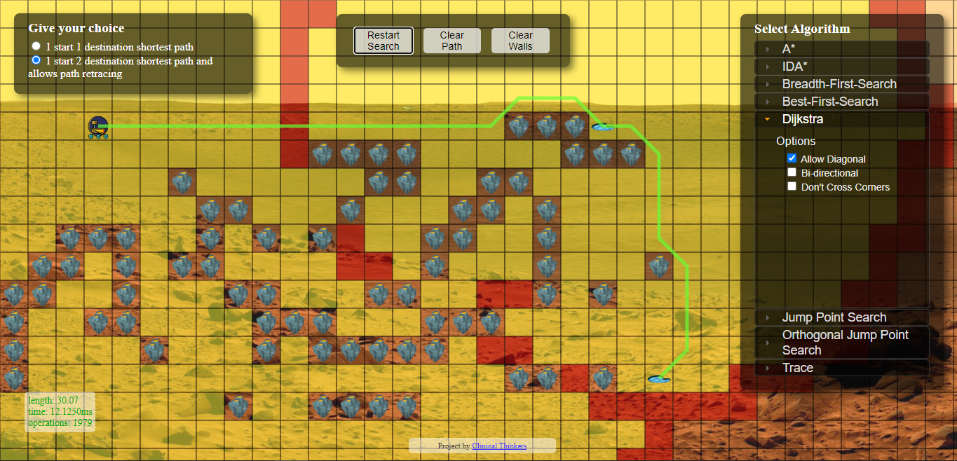

Amidst craters as obstacles, the rover finds the net shortest path across two destinations using **Dijkstra** algorithm, diagonal allowed.

**6) Two Point Working – No Diagonal:**

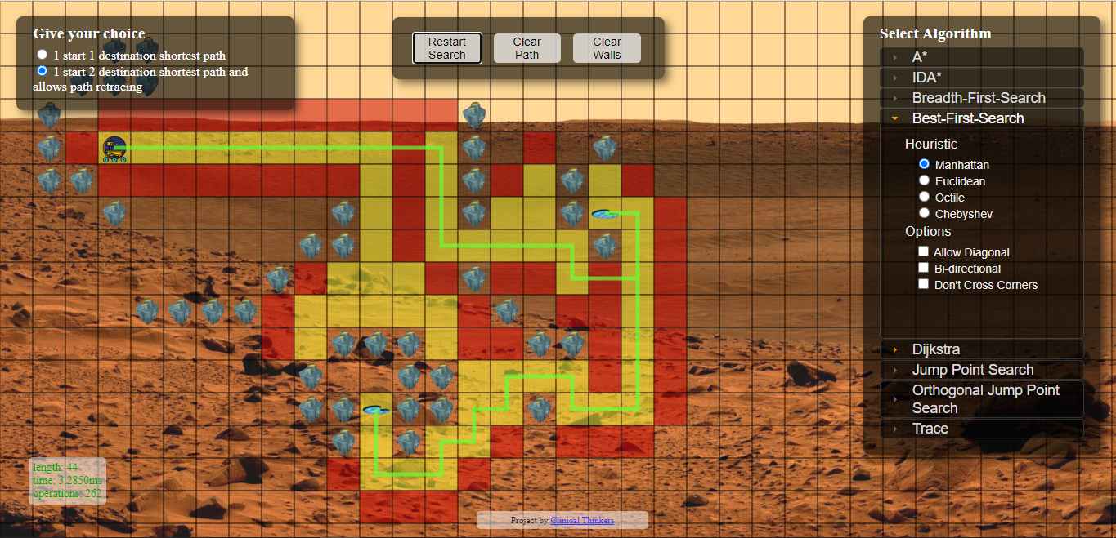The rover finds the net shortest path across two destinations using **Best First Search** algorithm, diagonal not allowed.

**7) Jump Point Search:**

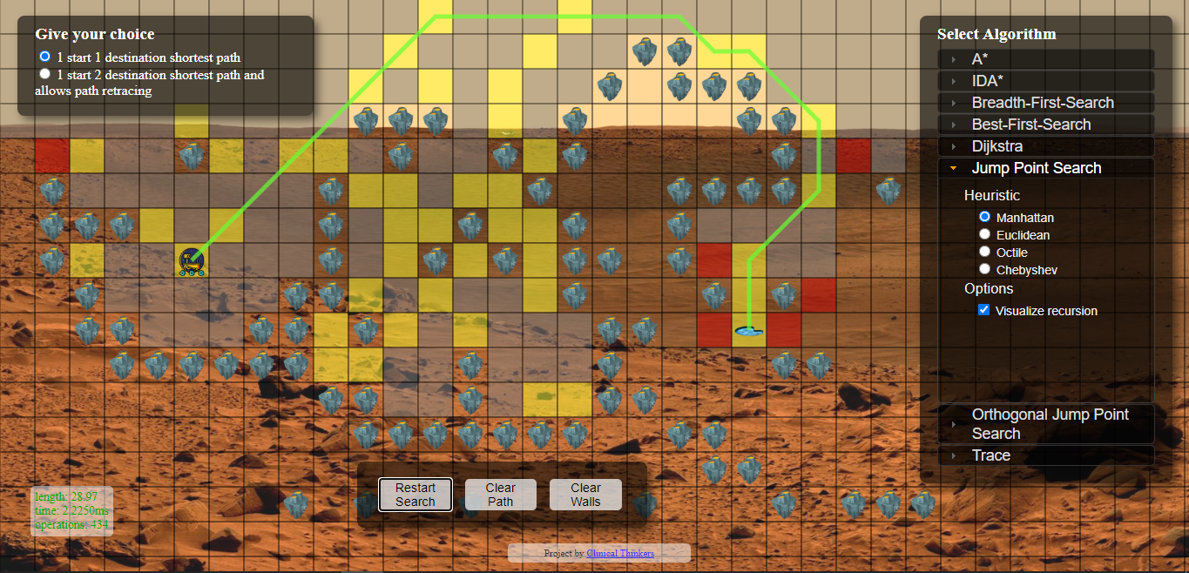

**8) Orthogonal Jump Point Search – 90 degree search:**

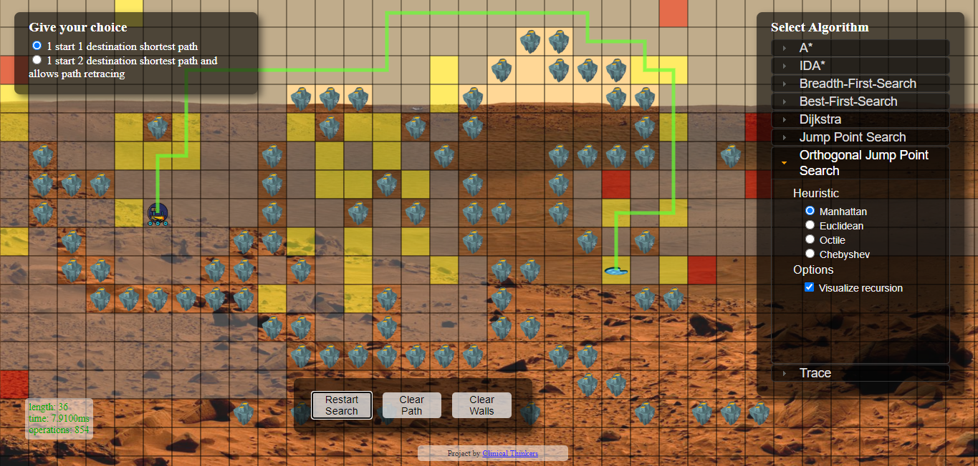

**9) Trace Search:**

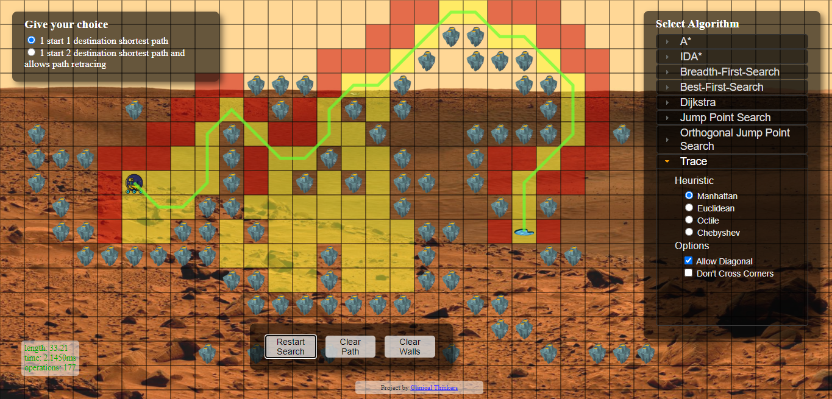

**10) Clearing the Path Alone:**

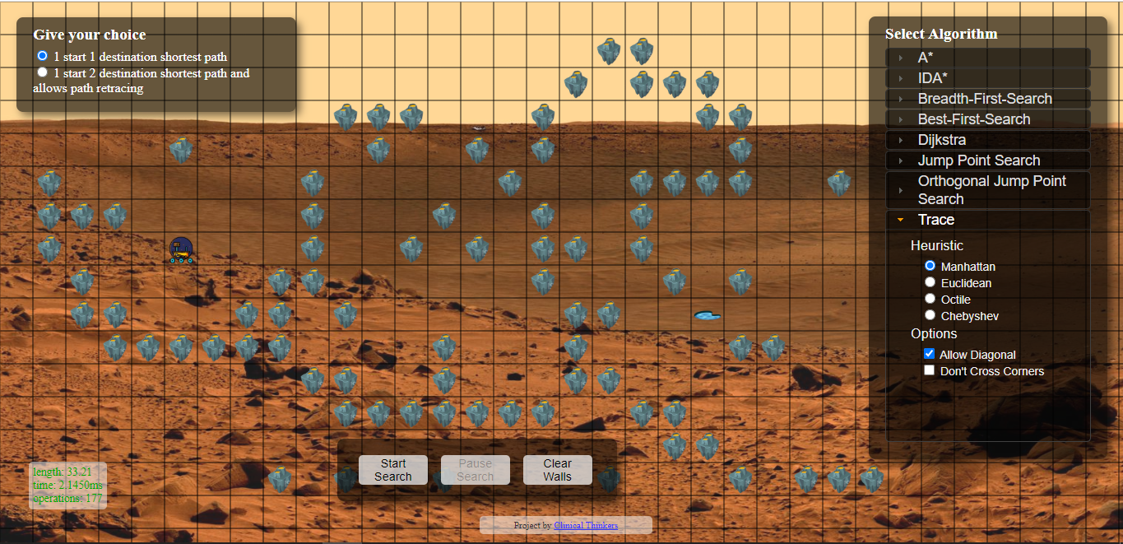

The above snapshot is taken after clearing just the path found by the rover, and not the obstacle walls.

**Thank You Note**

What a journey this has been for all of us!!

Turning back a month, reminiscing how amateur we were when we stepped into the project and now, the amount of knowledge we are left with is humungous.

Thanks to the **Microsoft AceHacker Team** for providing us such a platform to make the best use of it and certainly reap benefits from the same.

Thanks to **Vivek Sir** for organizing all our meetings and clearing our doubts.

Grateful to all the people who handled our webinar sessions and enlightened with your experiences and shedding light to many growing aspects of current technology.

Finally a huge thanks to our mentor,

**Mr. Ashutosh Upadhyay Sir** for spending your valuable time training and paving the way for us to successfully completing this project.

**Thank You All!!**